SEPTEMBER 7, 2018 | BRIEF NO. 18-2

Why Focus on Equity

The information in this brief was shared at the Equitable Assignment Challenge Summer Institute in August 2018. The institute was attended by faculty and administrators working to help close equity gaps in course outcomes in Washington’s Community and Technical Colleges (CTCs). The data points shared at the institute and in this brief are one example of many data points that help show the need to focus on equity in higher education. The data points in this brief primarily focus on historically underserved students of color (students identifying as American Indian/Alaska Native, Black/African American, Hispanic/Latino, or Native Hawaiian/Other Pacific Islander). These examples were selected to have a consistent group of people for the different comparisons – do not interpret the exclusion of other comparison groups to mean historically underserved students of color is the only group for which there are inequitable outcomes.

College Attainment in Washington
There are large gaps in college attainment rates in Washington State for historically underserved populations. See chart 1 for a summary of college attainment for 25-44 year olds in Washington State based on estimates from the American Community Survey. The chart has comparisons by gender, race/ethnicity, English speaking ability, family status, employment status, and annual personal income. Approximately five out of ten 25-44 year olds have a college degree, another two have some college, and three have no college. For historically underserved people of color or people who speak English less than “very well,” closer to two out of ten have a college degree, three have some college, and five have no college. For people who are single with children, unemployed, not in the labor force or making under $25,000 a year, closer to three out of ten have a college degree, three have some college, and four have no college.

Chart 1. College Attainment in Washington

When Students Leave the CTCs
Historically underserved (HU) student groups are more likely to leave the CTCs without completing their educational goals. See chart 2 for a comparison of HU students of color and other students in outcomes the year after leaving the CTCs. Leaving the CTCs means a student enrolled one school year and did not enroll in any CTCs the following school year. HU students of color were less likely to leave the CTCS with a postsecondary credential (29 percent vs. 37 percent of other students) and less likely to transfer to a four-year institution without a postsecondary credential (10 percent vs. 12 percent of other students). For those who did not leave with a postsecondary credential or transfer, similar percentages started a job with a salary of at least $30,000 a year (14 percent of HU students of color and other students). This leaves a ten percent gap with more HU students of color leaving without meeting any of these goals (47 percent vs. 37 percent of other students).

Chart 2. Gaps in student outcomes in the year after leaving a CTC

When Students Finish a CTC Course
Historically underserved (HU) student groups are less likely to finish a course with at least a 2.0 grade. See chart 3 for a summary of the gaps in course completion rates for HU students of color compared to other students in the highest enrolled commonly numbered courses (only including the top enrolled course in each of the listed subject areas). The gaps in course completion rates range from 3 percent in Spanish 121 to a gap of 14 percent in History 146.

Chart 3. Gaps in course completion rates

The data points in this brief are an example of how gaps in course outcomes relate to gaps in program outcomes and relate to gaps in educational attainment for the general population.

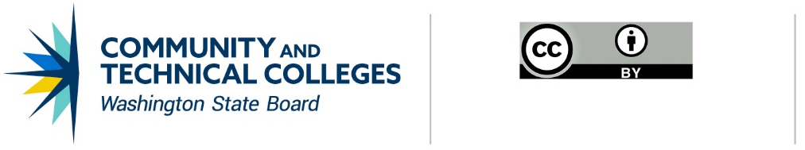
Note: Except where otherwise noted, this work is licensed under CC BY 4.0.

CONTACT INFORMATION
Devin DuPree
Policy Research Associate
p: 360-704-4384
e: ddupree@sbctc.edu

