EXPOSING & ANALYZING RETURN ON INVESTMENT (ROI)
IN CORPORATE FINANCING

COLGATE PALMOLIVE Company (C-P)

THE CHALLENGE:
What segment (Operating Division) of C-P deserves further investment based on ROI?

THE ASSIGNMENT:
- Complete the Answer Sheet – Table and Questions
- POST THE ANSWER SHEET IN CANVAS IN RESPONSE TO THIS ASSIGNMENT

Explore the Colgate Palmolive K-10 2015 Report to discover these issues:
- What are names of the two Product Segments that define C-P?
- Define these data for both segments for the year 2015:
  - Net Sales Revenue
  - Operating Income
  - Identifiable “employed” Assets
- Compute these Ratios:
  - Gross Margin (Profit to Sales) Ratio
  - Sales to Assets Raito
  - Return on Assets Ratio (Return on Investment (ROI))

THE PROCESS:
Access the Colgate Palmolive K-10 2015 Report through the SEC’s EDGAR SYSTEM:
CLICK ON THIS LINK (works on a PC):
https://www.sec.gov/Archives/edgar/data/21665/000162828016011343/cl-12312015x10k.htm

OR COPY & PASTE THIS ADDRESS IN YOUR BROWSER:
https://www.sec.gov/Archives/edgar/data/21665/000162828016011343/cl-12312015x10k.htm

- Use the Table of Contents to find the “Notes to Consolidated Financial Statements”
- Scroll down to and explore Note 15: Segment Information
- Find all the data and complete this table:

COLGATE-PALMOLIVE COMPANY 2015 DATA
2015 DATA | SEGMENT # 1 | SEGMENT #2
NAME
NET SALES
OPERATING INCOME
IDENTIFIABLE ASSETS
PROFIT MARGIN %
SALES TO ASSETS RATIO
RETURN ON INVESTMENT %

SAMPLE
YOU MUST USE THE SEPARATE WORD DOCUMENT
TO POST YOUR ANSWER SHEET IN CANVAS
ACCT203 ROI EXERCISE ANSWER SHEET NAME ______________________
CLICK ON THIS LINK (works on a PC) OR COPY & PASTE THIS ADDRESS IN YOUR BROWSER:

https://www.sec.gov/Archives/edgar/data/21665/000162828016011343/cl-12312015x10k.htm

COMPLETE THIS TABLE WITH THE DATA YOU FOUND AND COMPUTED

COLGATE-PALMOLIVE COMPANY 2015 DATA
2015 DATA | SEGMENT # 1 | SEGMENT #2
NAME
NET SALES
OPERATING INCOME
IDENTIFIABLE ASSETS
PROFIT MARGIN %
SALES TO ASSETS RATIO
RETURN ON INVESTMENT %
ANSWER THESE QUESTIONS:
- Which segment has the highest ROI – Please elaborate on why you think this happened.

- If you were on top management team at C-P and could only allocate extra funds for Capital Investment expansion into one segment, which segment would you choose and why?

- EXPLORE the C-P 10-K Report and name three parts of the 10-K Report where you found interesting data and why

10-K SECTION | INTERESTING INFORMATION & DATA | THIS DATA WAS INTERESTING BECAUSE:
IMPORTANT
- MAKE SURE THAT YOU ENTERED YOUR NAME ON THE TOP OF THIS FORM
- SAVE THIS WORD DOCUMENT AS:
ACCT203 ROI ANSWER SHEET NAME.docx
where “NAME” is your last name, i.e., SMITH
- POST THIS WORD DOCUMENT AS A RESPONSE TO THE CANVAS ASSIGNMENT

FOLLOW SCREEN SHOTS - COLGATE PALMOLIVE K-10 2015 Report

Click on this Hotlink
ACCESS COLGATE-PALMOLIVE DATA - GO TO "NOTES" & FIND NOTE 15: SEGMENT INFORMATION

OR COPY & PASTE THIS ADDRESS IN YOUR BROWSER:
https://www.sec.gov/Archives/edgar/data/21665/000162828016011343/cl-12312015x10k.htm

OPENING PAGE OF THE COLGATE PALMOLIVE K-10 2015 Report

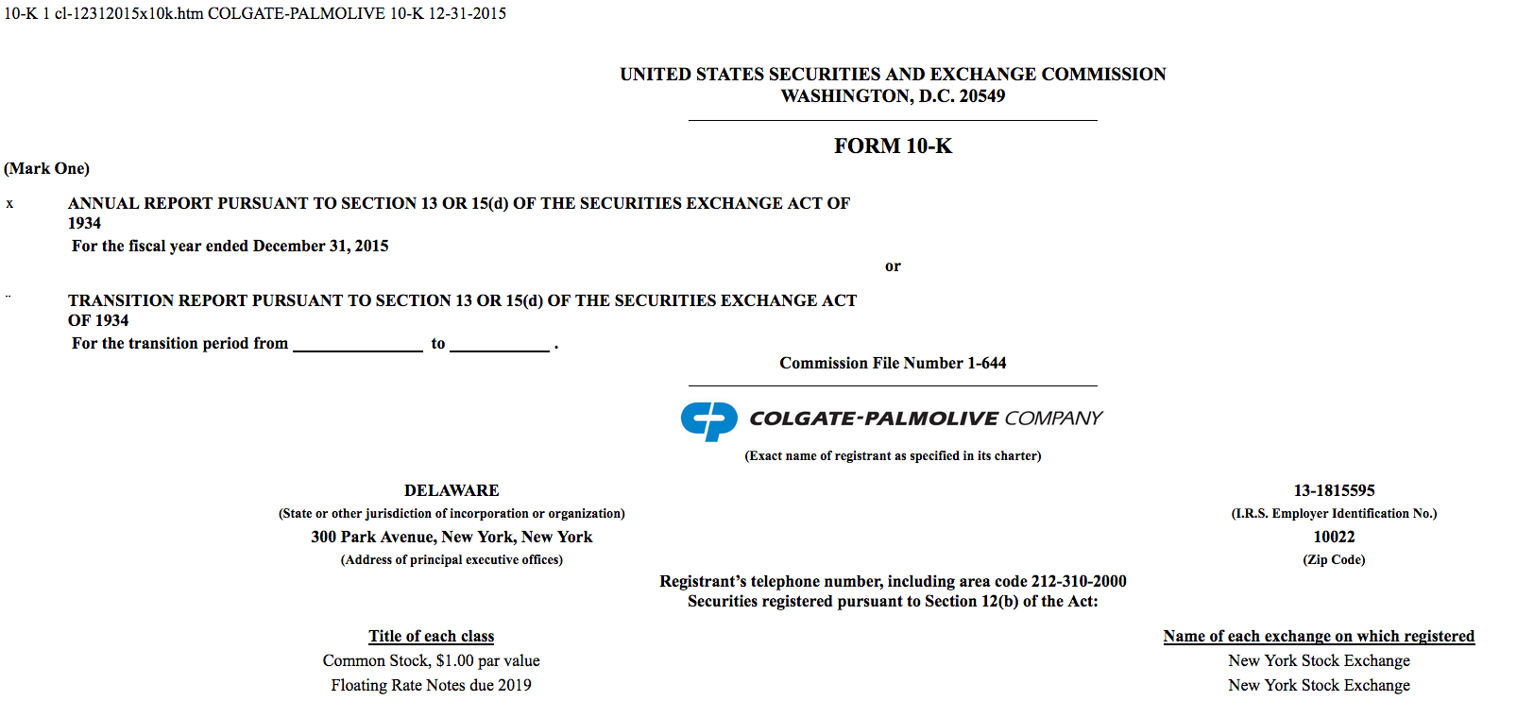

SCROLL DOWN TO THE “TABLE OF CONTENTS”:

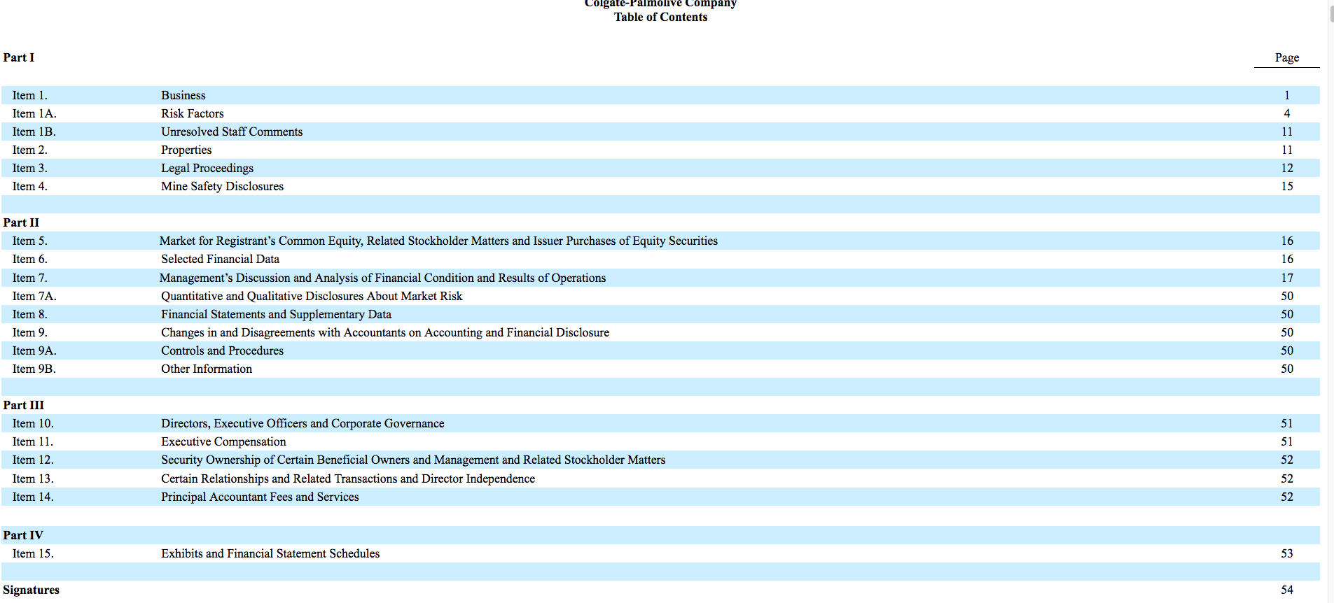

CLICK ON “PAGE 53” AND SCROLL DOWN TO “ITEM 15”:
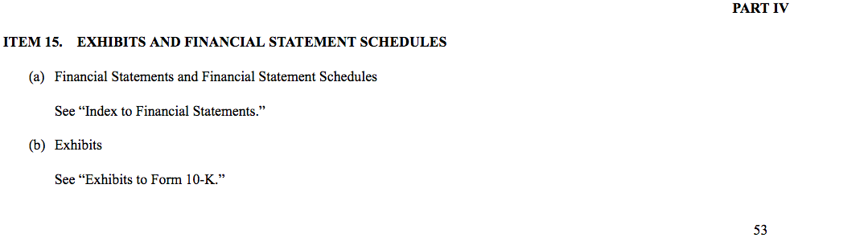

SCROLL DOWN TO THE “INDEX TO FINANCIAL STATEMENTS”

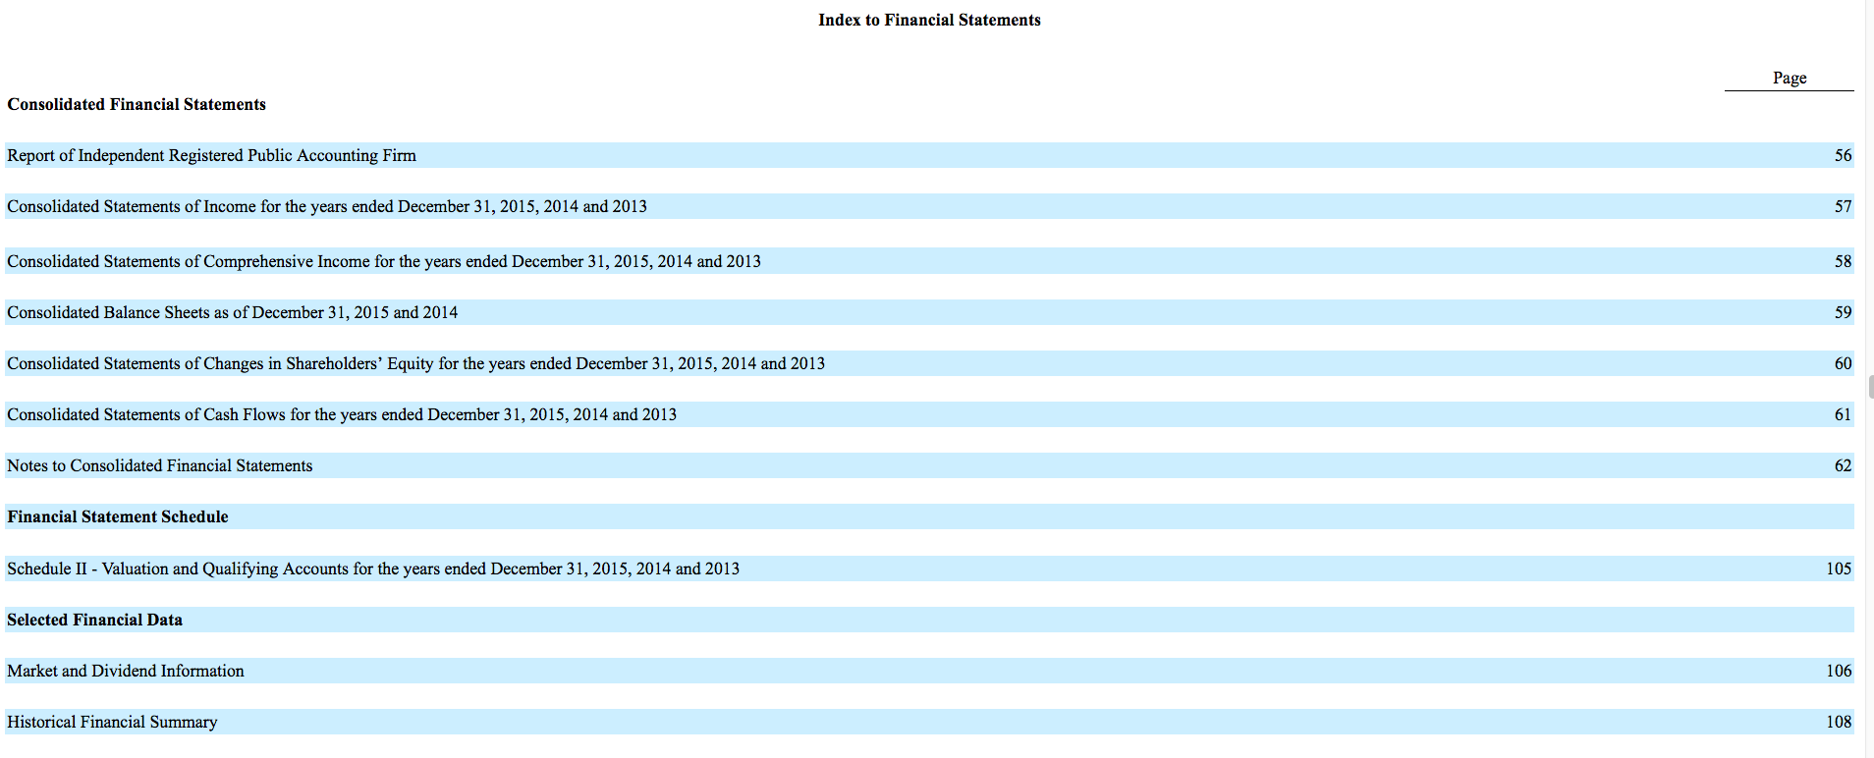

CLICK ON “NOTES TO CONSOLIDATED STATEMENTS”

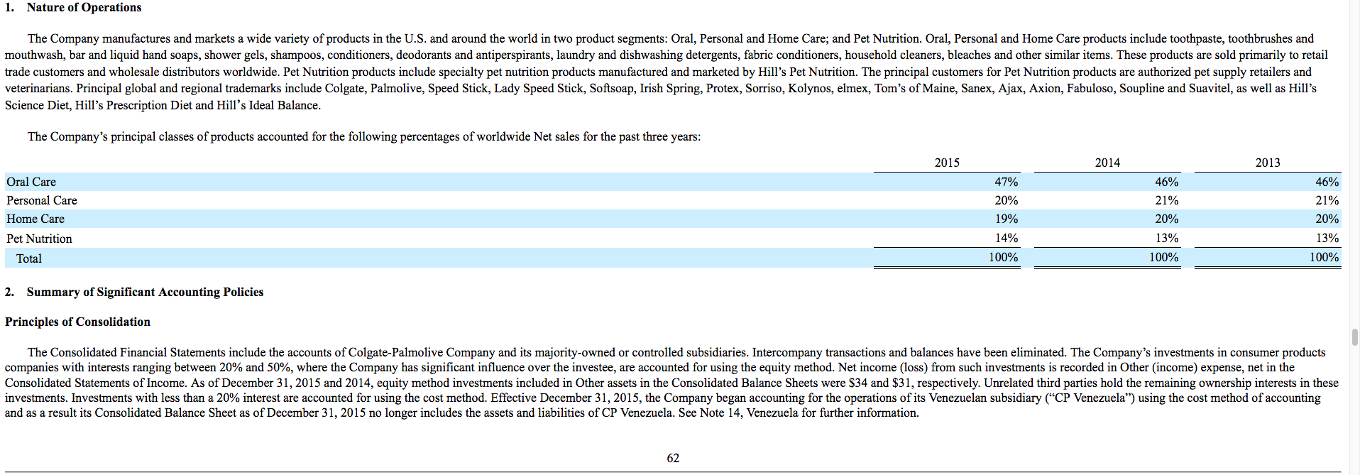

SCROLL DOWN TO NOTE 15 (Page 96):
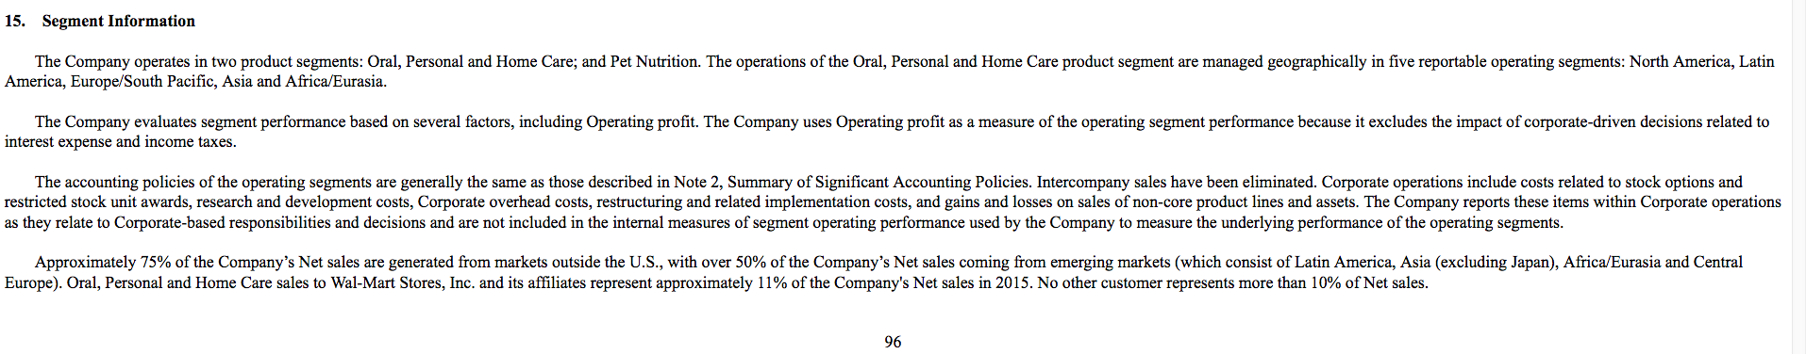

SCROLL DOWN TO SALES DATA (Page 97):

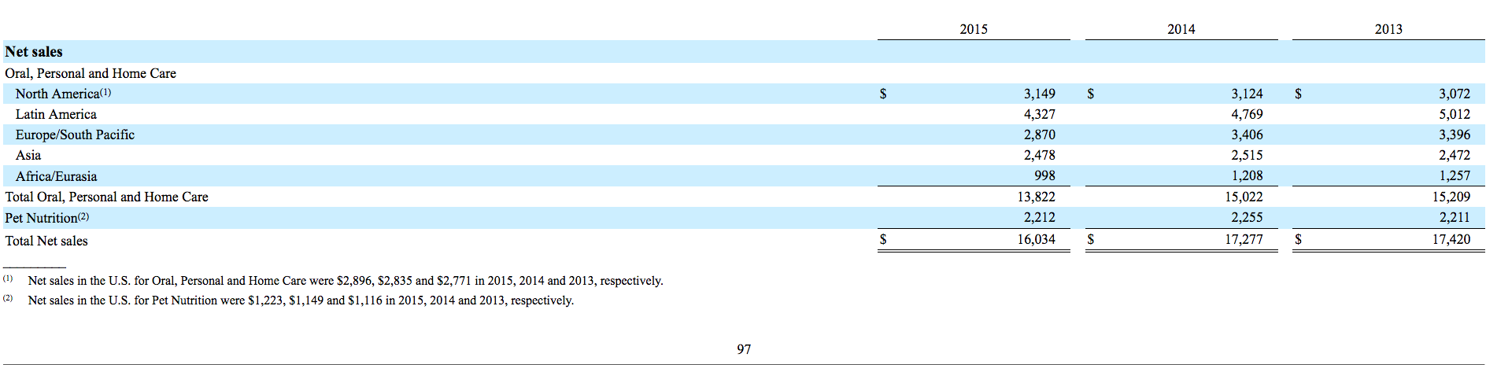

SCROLL DOWN TO PROFIT DATA (Page 98):

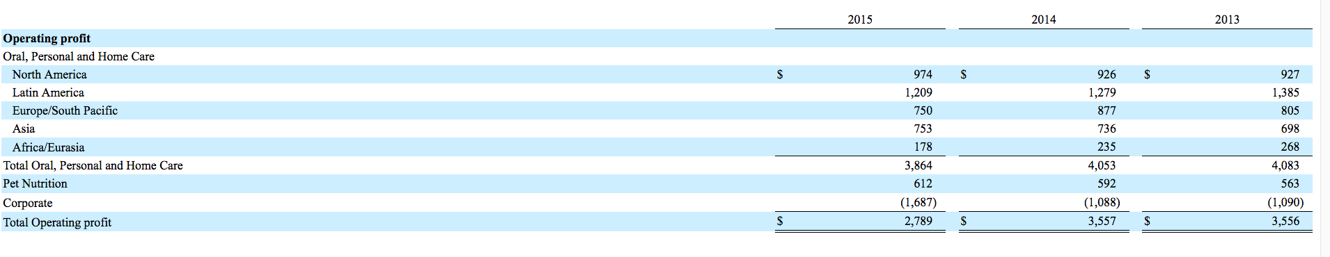

SCROLL DOWN TO IDENTIFIABLE ASSETS DATA (Page 99):

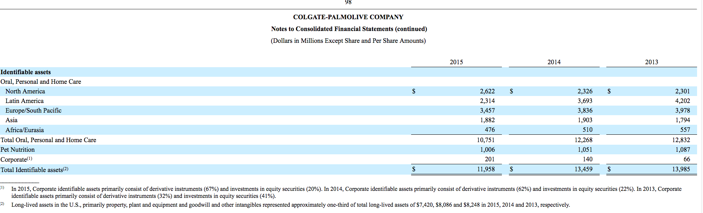

SCROLL DOWN FURTHER AND REVEAL THEIR STOCK PRICE HISTORY (Page 107)

