Create Your own Practice Course
Canvas Guides: Creating a Course

You now have the ability to create a Canvas shell for practice purposes and/or as a repository. There will never be students in the course, it lives outside the registration system and is yours alone to manage.

Note: This is recommended for individual sandbox use only. For department or community shells to be used more widely, please contact eLearning as there are more options in setting up those shared courses than creating your own for practice.

IMPORTANT to Know
- When you choose CREATE COURSE from the dashboard, you will name the course
- You are the creator and manager, not eLearning
- Write down the name of the course you created so you can find it again
  - If you want to add another instructor, contact eLearning
  - eLearning cannot find the course if you don't know the name
- Students will never be in the course
- You can create as many as you need or none at all!
- You can create course materials and copy/import into a "real" course

Use the course as a playground to:
- Play with HTML and design
- Use as a repository for materials
- Make a course to share with another faculty
- Practice any new features in a specific Canvas course before they are implemented in all courses
Canvas guides: How to manage Feature options by course
To view any new features that you can turn on at the course level
- Go to settings in the course navigation menu
- Choose the Feature Options tab at the top of the page
- Click on the slide button to turn it green to enable that feature
In the example below of the feature option page, the upcoming new​ rich content editor (RCE) slated to be the new RCE starting January 16, 2021 is available in the Feature Option choice. You can create a course to see how it works! The RCE is the edit ribbon for you and students when you choose edit. It is not recommended to turn it on for your current fall classes. eLearning send training materials and information soon.
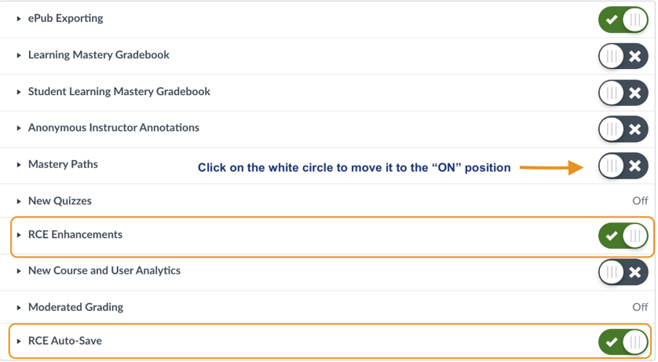

How Do I Create a Course?
- On your dashboard, choose Create a Course, located in the right panel on a desktop computer, under recent feedback
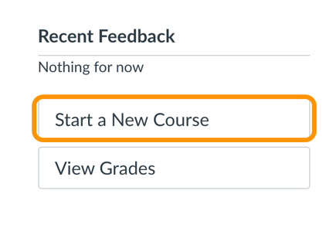
- In the dialog box, write in a name and write it down somewhere for future reference

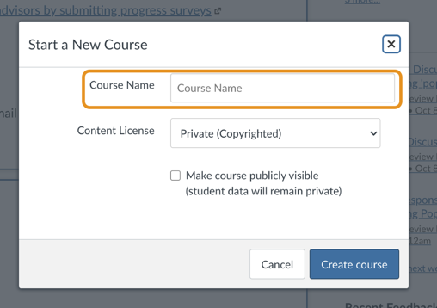

  - Leave it private
  - Do not check, Make course publicly visible
- Choose Create Course
- Once you choose create course, it will open to your new empty Canvas shell. You will automatically be in that course as a teacher. (Choose People to see your name)
Did you forget to name the course? It will show up as unnamed by default. No worries. You can name it in the course settings.

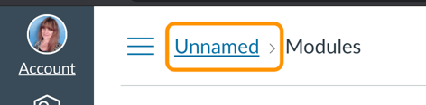
- Choose settings in the course menu navigation
- Create the name and write it in the text box
- In Course code: You can copy & paste or abbreviate
- Scroll to the end of the Page and choose UPDATE SETTINGS

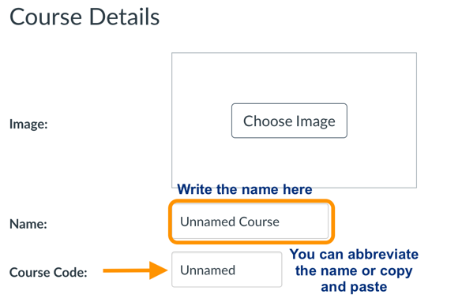

- The name in the course code box appears in the breadcrumbs on the top of the course

