Uploading Media Files into Panopto
If you recorded a video or audio file using a different type of recorder, you can upload your media file to Panopto using the Create button.
- Click on Panopto Recordings in the course navigation from any of your courses (Left-hand side)
- Click the Create button on the top panel, then select Upload Media
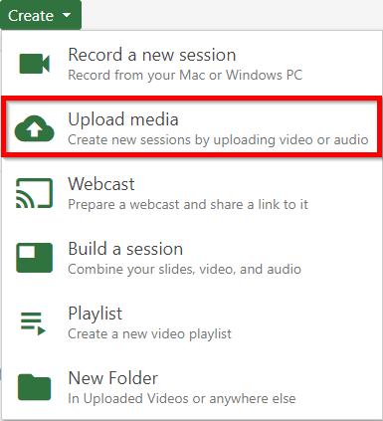
- You will be prompted to upload your file from your computer.
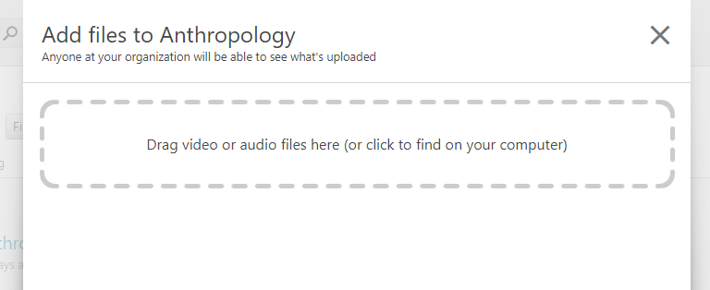

- Wait for Uploading to finish, which may take a while based on the size and amount of files. Note: there are certain factors, such as bitrate, aspect ratio, file size, and video length, can impact the time it takes for the video to process. For supported media file types, see Learn About Supported Media File Types for Uploading.
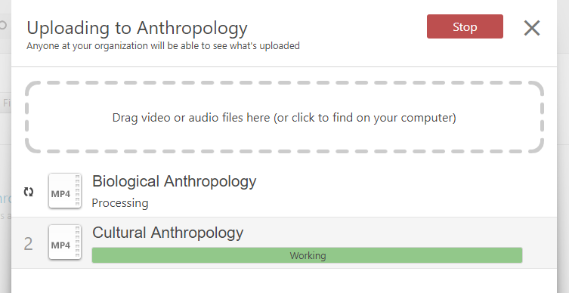

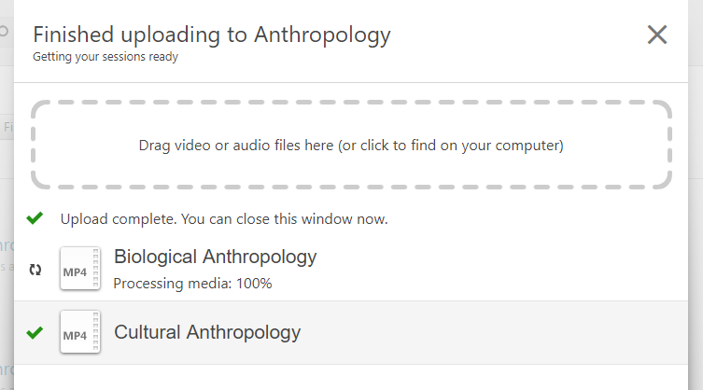

- When processed, the session can be edited right away. You can close the window when it is finished uploading. Once the publishing completes, you will be notified that the sessions are ready to view.
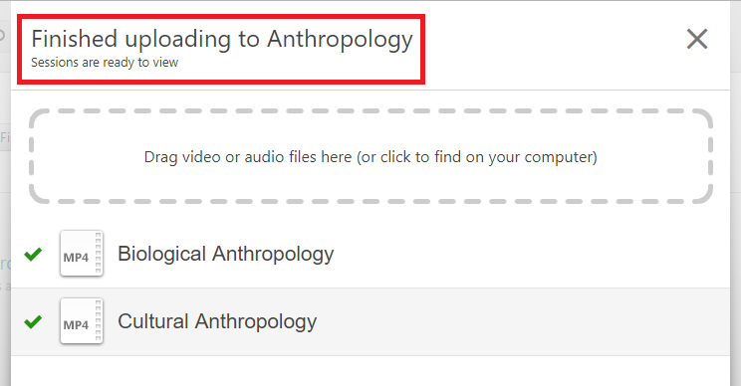

Note: If you run into any issues or have any questions about uploading media files int
Panopto, please contact north.elearning@seattlecolleges.edu

