Student Guide: Recording Video with Panopto Capture

Panopto Capture allows you to easily record audio, video, and entire screens or application windows. A student can access Panopto Capture from directly within their browser, and no download is required. An instructor needs to have created an assignment folder for the students to record a Panopto video.

Note: Panopto Capture works on Windows, Mac and Chromebooks. With Google Chrome, Firefox and the new Microsoft Edge as the browsers.

Getting to Panopto Capture
The first thing you need to do is log into your Canvas account and open your class. On the course navigation on the left hand side of the screen, you will click on the Panopto Recordings link. If you don’t see a Panopto Recordings link on the course navigation, this is because your instructor has hidden the Panopto Recordings link and they will need to make it visible in order for you to be able to find the Panopto Capture tool.

Click on the “Create button”. Then, click on “Panopto Capture”.

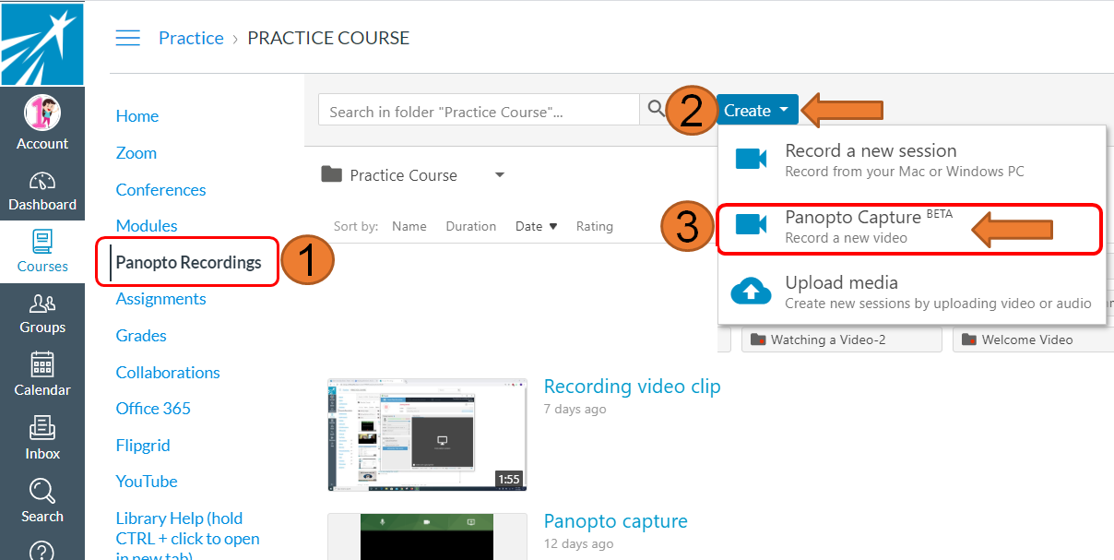

Panopto Capture opens in a new browser tab.

Recording with Panopto Capture
You are going to make sure that you allow the browser to use your microphone and your webcam. Also make sure to select your window to share the screen. Your instructor may ask that you show a PowerPoint or a Google Slide or some other work while you talk on your video.

Choose your Audio and Video Sources
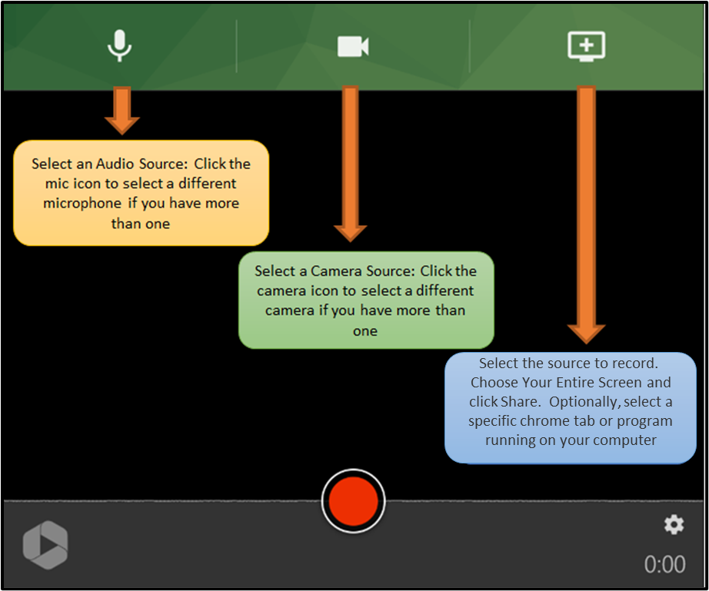

Select your Screen or Application Source
To record a screen, application window, or individual chrome tab, select the monitor icon with the plus sign in the upper right of Panopto Capture. If you do not need to record any screens or applications, you can skip this step.

A window will open. Here you can choose the source to record.
- To record everything that happens on a screen, choose Your Entire Screen. Then, select the screen to record and click Share. Optionally, select Share audio to add the audio from your computer to the recording
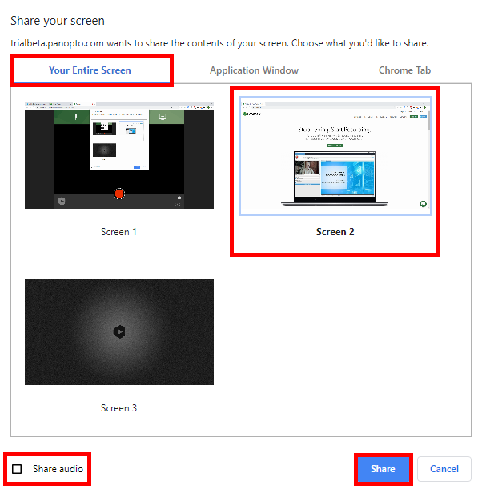

- To record everything that happens in one application window only, choose Application Window. Then, select the application to record and click Share.

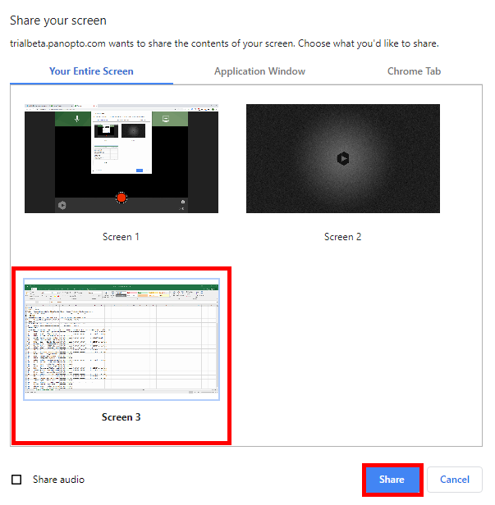

- To record everything that happens in one Chrome browser tab, choose Chrome Tab. Then, select the tab to record and click Share. Optionally, select Share audio to add the audio from your computer to the recording.

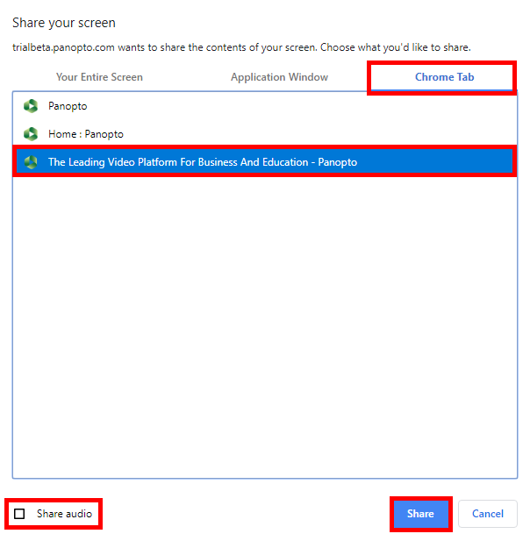
- After choosing one screen or application source, you may add additional sources by selecting the monitor icon again.

Preview and Settings
You will see a preview of your selected video sources in Panopto Capture. To remove a video source, hover over the preview of the source and click the X. To preview a source in full screen, hover over the preview of the source and click the full screen icon.

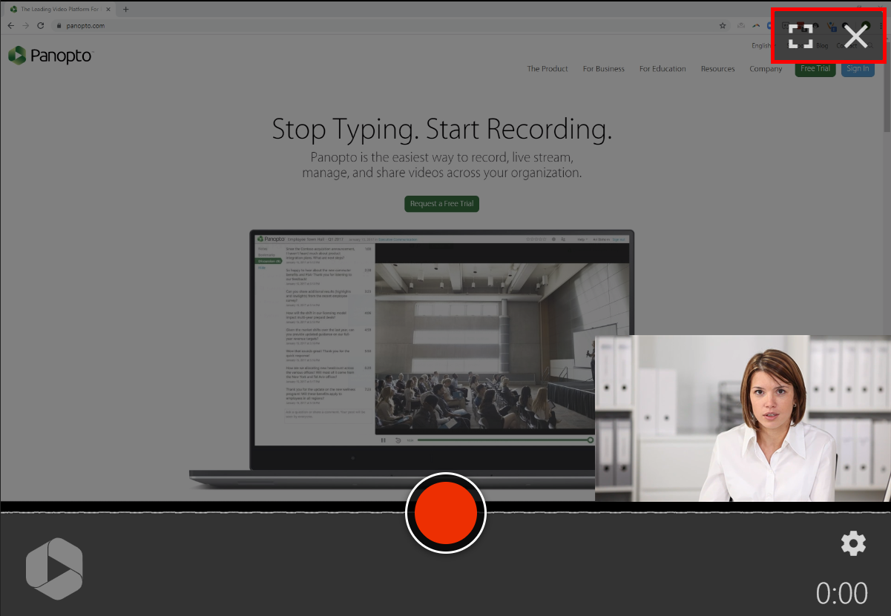

Hit Record
To begin recording your video, click the red circle button at the bottom center of Panopto Capture
You will see a 5 second countdown on screen, and then the recording will begin.
To stop recording, select the red square button at the bottom center of Panopto Capture.
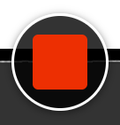
The video will immediately begin to upload. Do not close the Panopto Capture browser tab until the upload is complete.

Video Upload and Processing
Once the recording is stopped, the video will immediately begin uploading to your assignment folder. Make sure to select the right assignment folder if you are taking more than one class that requires you to record Panopto videos.

Give your video a name.

Do not close your browser tab until uploading is complete. Uploading is complete when the status bar reads Getting your video ready for editing
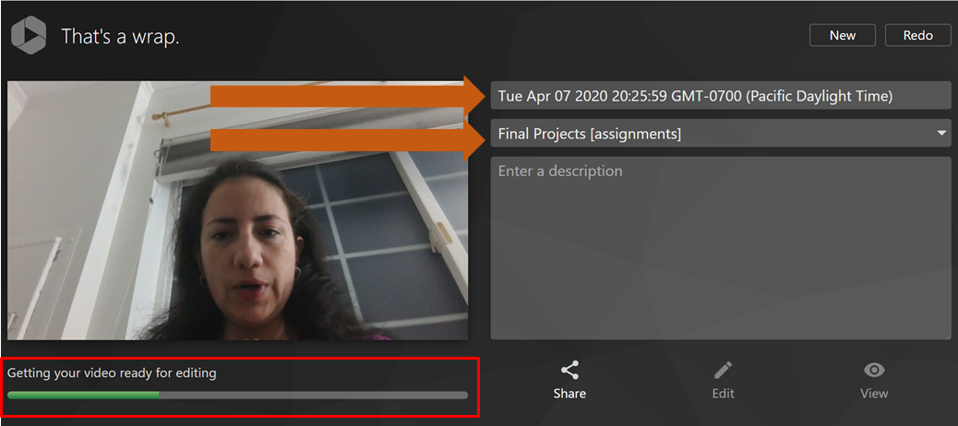

When the video is finished processing, you can also begin editing or viewing your video.

If you need to record your video again instead of saving it to the video library, click Redo in the upper right corner

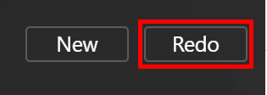

If you would like to record another video, click New in the upper right corner.

