Canvas Conferences Faculty Guide

Overview

Faculty can schedule Conferences to meet virtually with their students. Students can use Conferences to meet within their student groups. The webconference tool used by Canvas is BigBlueButton. We recommend GooChrome and Firefox browsers for best results.

Preparation
- As the presenter, you can join the audio using headphones with a microphone.
- In order for students to join the conference, you must have “Conferences” in the course navigation bar. To add it, open the course and click SETTINGS > NAVIGATION. Drag “Conferences” into the active items. At the bottom of the screen, click SAVE.

Set up a Conference
- Open Chrome, Firefox
- Log into Canvas and select your course
- In Course Navigation, click the Conferences link.
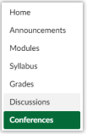
- Click the +New Conference button in the top left corner of the screen.
- Type a name, duration, and description. Optionally, enable recording or set no time limit. NOTE: Recordings are automatically deleted after 14 days.
- By default, all members in the course will be invited to the conference. If you unclick Invite All Course Members, you will see the option to select individuals.
- Click Update.
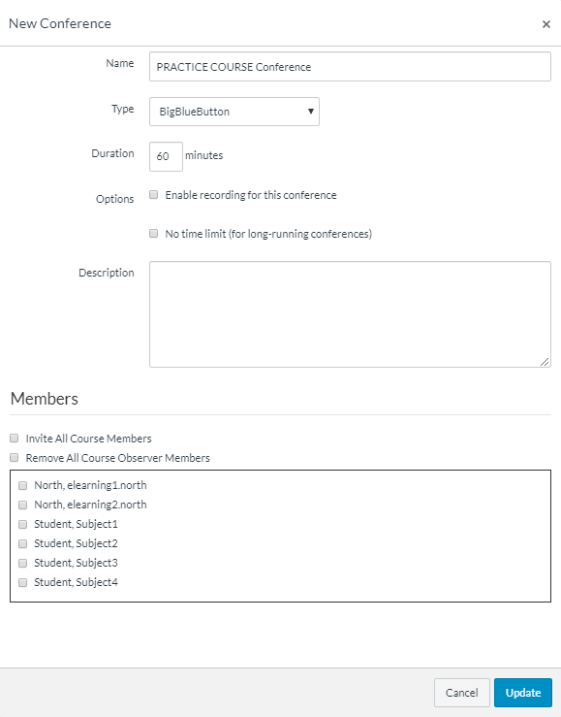

Start a conference & join the audio
- In Course Navigation, click the Conferences link.
- Next to the conference you want to start, click the Start button.
- Canvas will direct you to the conference room for your conference
- “How would you like to join the audio?”
  - Select Microphone to use your headphone and microphone. You may be prompted to allow permission to use your microphone. Select Allow.
  - The Audio Test will appear. Speak a few words and verify that you can hear them through your headphones (not your speakers). If the audio is working, click Yes.

The BigBlueButton interface:
Lower Toolbar
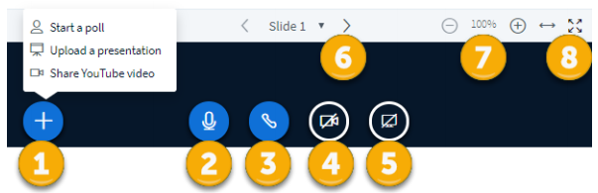
- Click + to start a poll, upload a presentation, or share a YouTube video.
- Mic icon mutes/unmutes yourself.
- Phone icon removes you from the audio conference.
- Camera icon turns on/off your webcam.
- Click the Screen icon to share/stop sharing your screen. If you have multiple monitors, you will be prompted to select a monitor. Note: Keep in mind that when you are sharing your screen, participants can see everything on your screen, so it is a good idea to close email, instant messaging, alerts, etc.
- Navigate through slides using the left and right arrows.
- Zoom in and out of the presentation using the -/+ buttons.
- Fit the presentation to the width of the screen or set it to fill the screen using the fit buttons. Press ESC on your keyboard to exit full screen.

Upper Toolbar
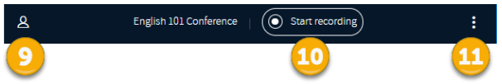
- The User List Toggle hides/shows the left sidebar.
- If you enabled recording when settings up the conference, the Start Recording button will appear at the top of the screen. Users will be notified by a message onscreen when you start recording. Click the recording button again to pause the recording. The recording will stop when you end the conference. NOTE: Recordings are automatically deleted after 14 days.
- Click the 3 dots for additional options, including:
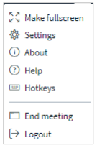

Left Sidebar
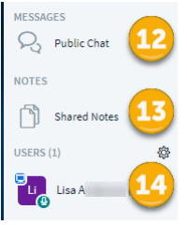

- The Public Chat window contains the welcome message for the conference and contains all the chat messages throughout the conference.
- Multiple users can contribute to Shared Notes. Anyone can click the Import/Export icon in the Shared Notes toolbar to export the notes as a Word document, PDF, etc.
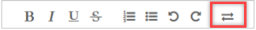
- The Users panel displays the users in the conference. You can mute users (including yourself) by clicking on a name and selecting Mute user.

Annotation Toolbar

The annotation toolbar only appears when sharing files or slides. It does not appear when sharing your screen. Use the pen to mark-up the presentation on screen. Click the buttons to select a pen type, thickness, and color, or to undo your annotations. Click the Multiuser Whiteboard icon at the bottom of the list to allow others to annotate at the same time.

End a conference

Close the browser tab or, from the top right corner of the screen, click the (3 dots) icon and select End Meeting.
There is often a lag between when you end a meeting and when the Canvas Conferences page is updated. The Conferences page may display “In Progress” for several minutes after the meeting is over. To manually update the page, click END.
Once a conference is ended, it moves to the Concluded Conference section and cannot be reopened.

View a recorded conference
To view a recorded conference, in Course Navigation, click the Conferences link. Find the concluded conference. Click on it to open its details. Click the presentation link to open and play the recorded conference. NOTE: BigBlueButton recordings are automatically deleted after 14 days.
References This document was created from documents published by the Canvas Doc Team https://community.canvaslms.com/community/answers/guides/canvas-guide
For help with BigBlueButton, watch these short tutorial videos: https://bigbluebutton.org/videos/

For more information on Canvas Conferences, please contact Diana Benavides. Diana.Benavides@seattlecolleges.edu. Ext: 3724

