Zoom Polling for Meetings

Overview

The polling feature for meetings allows you to ask multiple choice polling questions. You will be able to launch the poll during your meeting and gather the responses from your attendees to engage your audience and allow participant input.
To turn on the polling feature, go to Polling for Meetings and scroll down to For Your Own Meetings.
Note: If you are making a recording of the meeting, poll results do not appear in the recording. Please download the report for polling results.

Requirements
- To launch polling, the host must be using the Zoom Client for Meetings desktop application on PC, Mac, or Linux
- Only the original meeting host can use polling. If host control is transferred to another participant, the new host will not have polling ability
- Attendees using the desktop application or the Zoom mobile app will be able to participate in polling, but those using a web browser (such as Chrome or Firefox) are unable to view or participate in polls.

The web client of Zoom has limited features and functions as you saw polling is one of those.
For more info on: Zoom web client
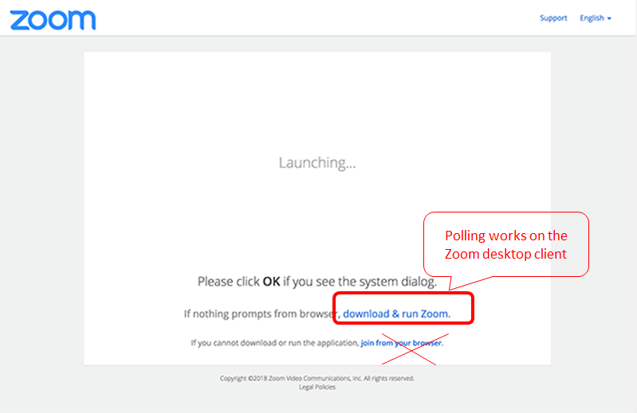
If you want to ensure that your students/participants use the desktop application, you can disable the show link to join from browser on your account settings:
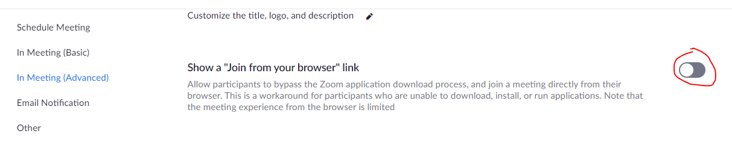

Accessing Poll Results

If you are making a recording of the meeting, poll results do not appear in the recording. Follow the steps to download polling results.
- Go to zoom.us and Log In.
- Select Reports.
- Select Meeting
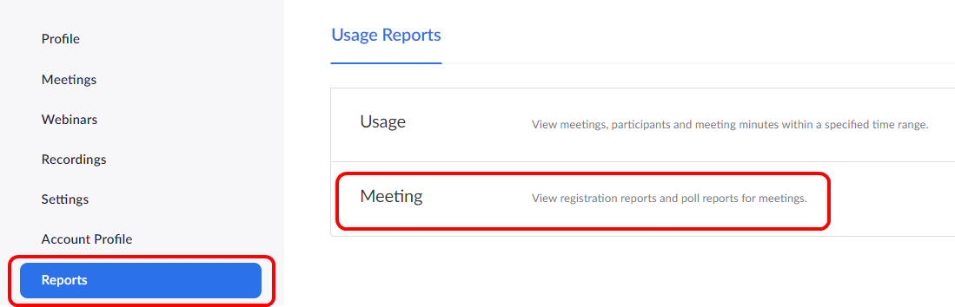
- For Report Type, select Poll Report
- Enter a date range for results and click Search.
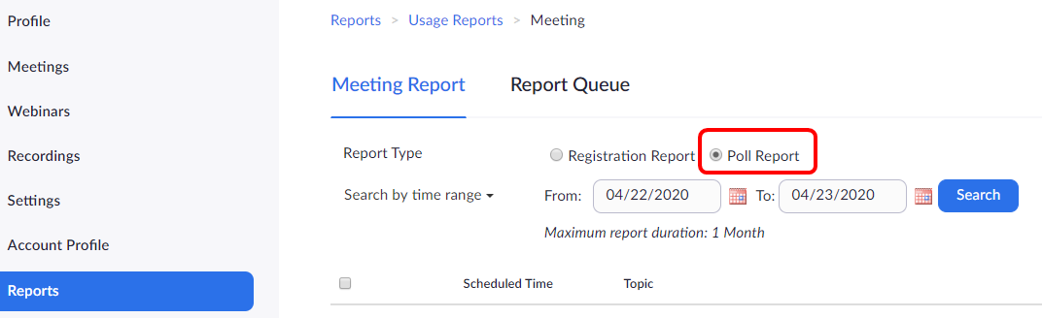
- Select Generate to the right of the meeting you wish to get poll results for. The Report Queue opens with all generated results.
- Select Download to download the poll results to a .csv
- Poll results open in a .csv

Learn More
- For additional instructions on creating a poll, launching a poll, and downloading a report of poll results, see Polling For Meetings in the Zoom Help Center.
- For ideas about how to use polls to engage your audience, see 3 Ways To Use Polls In Meetings on the Zoom Blog.

