Finding & Sharing Your Zoom recording in Panopto
When you choose "Record to the cloud", your Zoom cloud recordings will be sent to Panopto automatically. With our Zoom-to-Panopto integration, you are going to be able to find these recordings in your My Folder in the Meeting Recordings subfolder in Panopto.
Your recording in Panopto will include, shared screen with speaker view and it will include gallery view when there was no screen share taking place at any given time of your video. The chat conversations during Zoom will be stored in the Discussions area of Panopto. The transcripts done by Zoom will be stored as closed captions in Panopto.
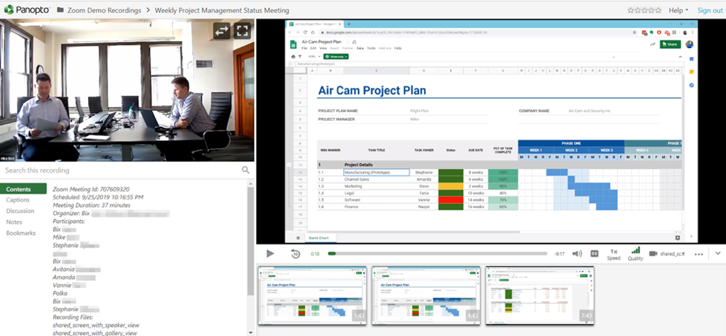

Steps to find your Zoom cloud Recording in Panopto
1. Choose Panopto Recordings from your Canvas course navigation menu. If it is not visible, choose settings in the course navigation menu>Navigation tab>Move Panopto Recordings to the visible area>Save
2. Choose My Folder
3. Click on the Meeting Recordings subfolder
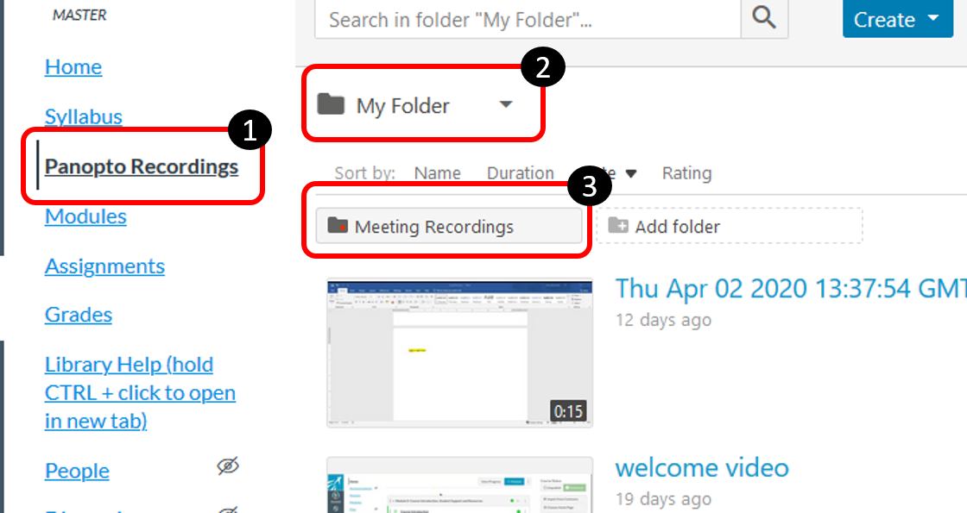
You will see your list of Zoom cloud recordings.
Your Zoom cloud recordings are saved in a private folder that only you (the host) has access to. If you want to share any recording with students in a class, you need to change the who has access to the video. Click on the share button, it will be visible when you use your mouse pointer to hover around the video’s thumbnail.
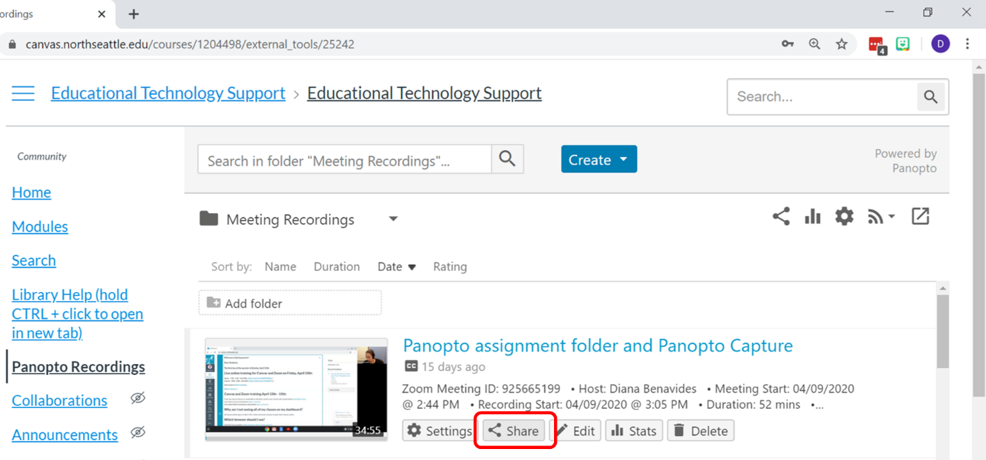
On the who has access section, click on the down arrow at the end of where it says, “Specific People”.

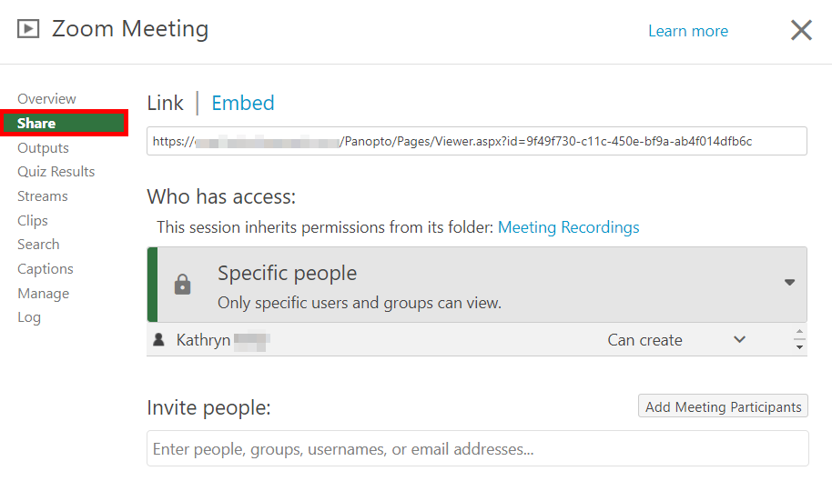
Choose "Anyone with the Link"
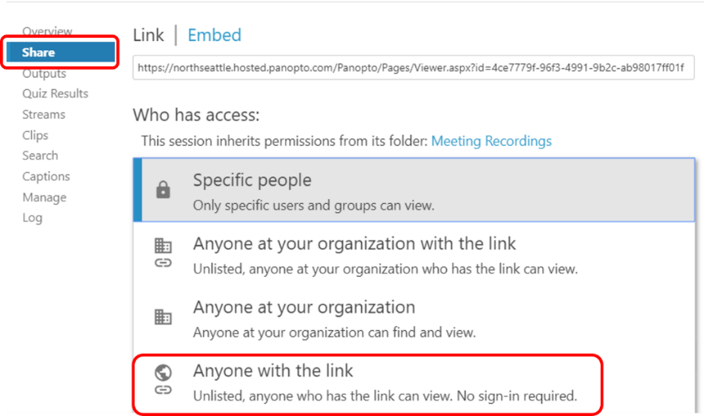
Make sure you hit “save changes”. Now, you can copy the link of the video and share it in Canvas as a link in your module.
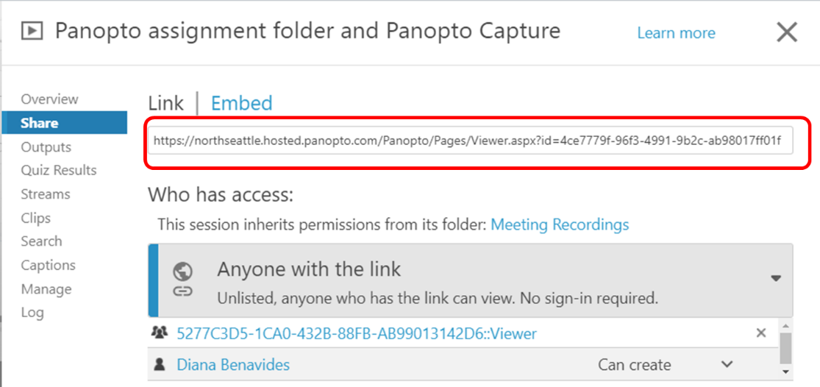
Click on the add item button in your Modules to add an External URL

Then, paste the URL in the respective box and add a name to the link

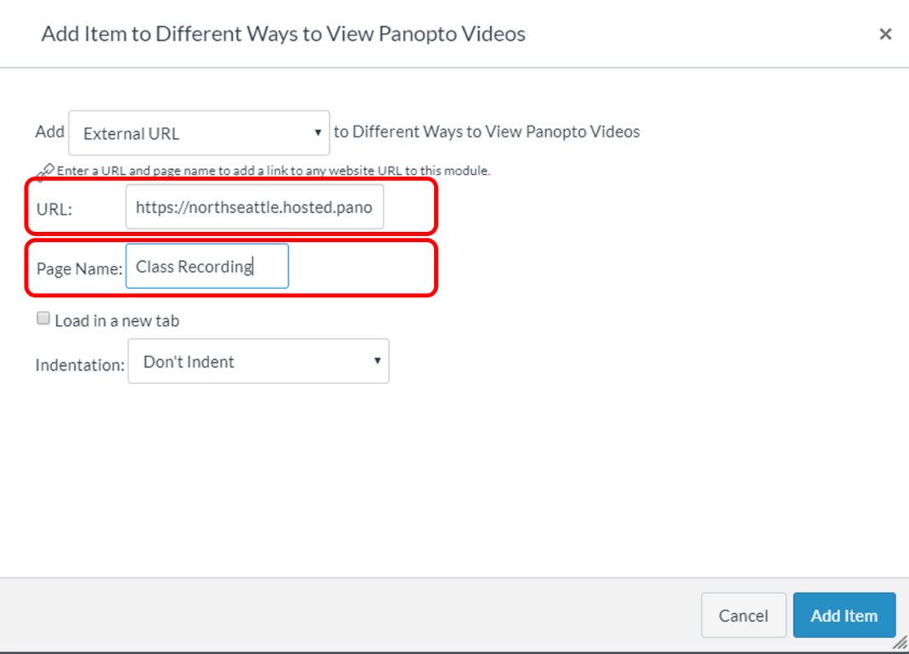
Last, click Add Item.
Note: You can also move or copy the video from this "Meeting Recordings" folder to your class folder.
How to Copy and Move Sessions in Panopto

An alternative to sharing a link

Embedding a Panopto Video in a Canvas Page

If you want to embed a Panopto video in a Canvas page, you can use the Panopto embed tool within the text editor.

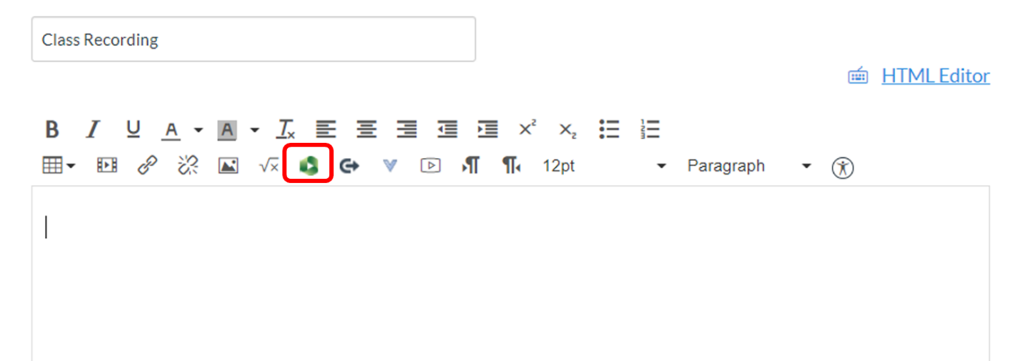

Find the folder where the video is, select your video and insert it in the page.

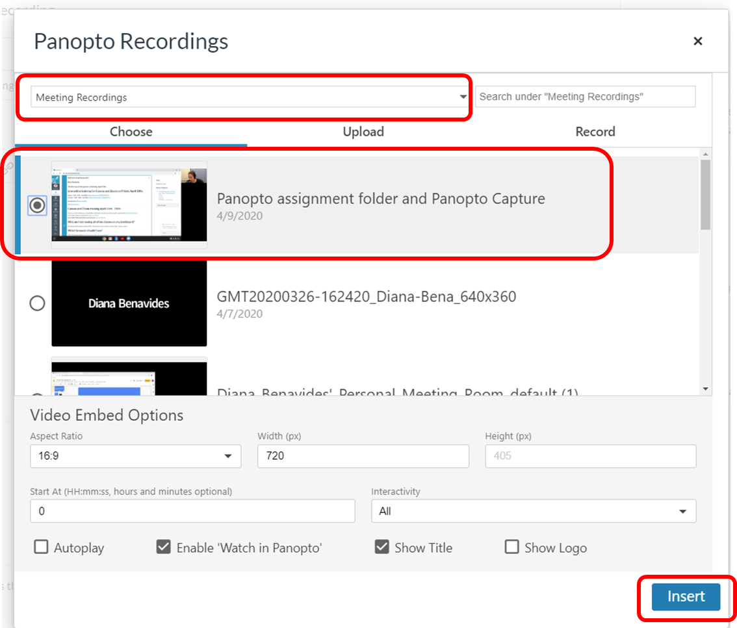
Note: To find your Zoom Recordings in Panopto, ensure that your email address used in your Zoom account matches your default email in Canvas.

If you cannot find your Zoom cloud recordings in your private folder in Panopto, please contact eLearning to help you locate them.

