Panopto Assignment Folder Faculty Guide

Overview

An Assignment Folder is a subfolder that shares its user list with its parent folder but gives the users (students) some additional privileges. Assignment folders enable Viewer users in their parent folder to create and manage their own content while preventing them from viewing other users' content that has not been explicitly shared or made public.

Creating an Assignment Folder

- Open the Panopto Recordings tab from your course navigation (left-hand side). Once opened, click on the folder settings icon on the top right.
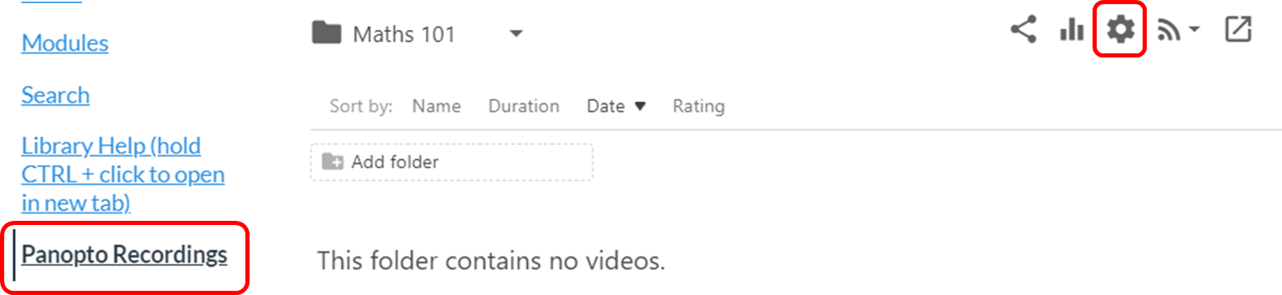
- On the Overview screen, click on the button labeled "Create Assignment Folder"
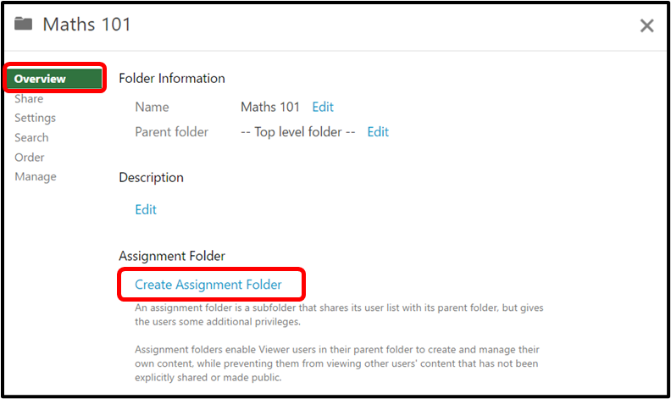
- Once the assignment folder is created, you will see a new link that is <name of folder> [assignments]
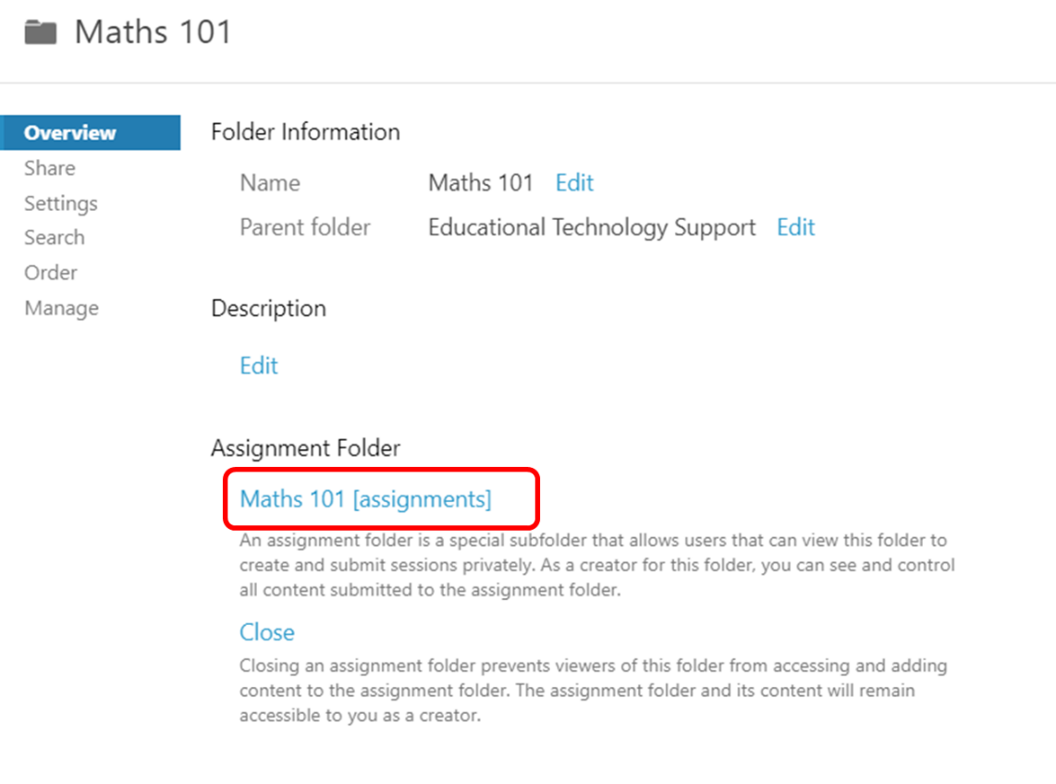
- On the main interface page, you will see that the folder has been added as a subfolder to the original with the word "[assignments]" added to the end.
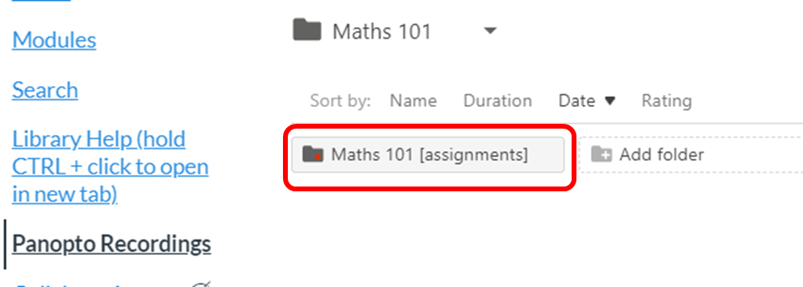
- Now viewers that are shared to the original "Maths 101" in this example will be able to add content to the newly created [assignments] folder.

Recording to an assignment folder

Note: If this is the first time a student is recording a Panopto video, they will need to install the Panopto software on their Windows Pc and or Mac. Chromebook users can use the Chrome browser based Panopto recorder that does not require installation. Please refer to the Student guide to record with Panopto Capture.
- Login to the Panopto Recorder.
- Click on the large arrow button to select the folder where you wish to record. In this example, the user "Student A" was given access to "Maths 101" so they will see and be able to select the associated [assignments] folder under their choices.
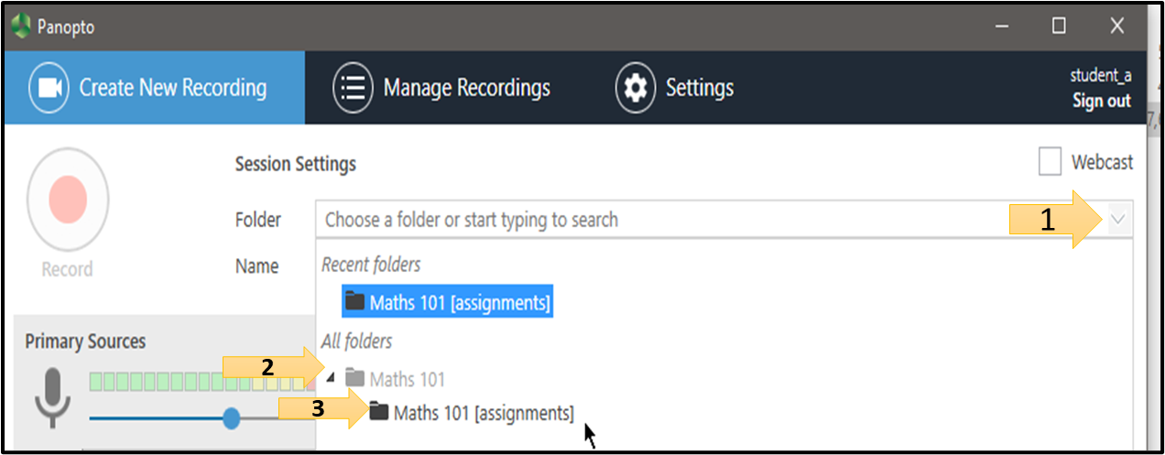

- Click on the large red Record button to begin recording your session.
- After recording, you can verify that the session has been recorded by logging in to your organization's server and clicking on your assignment folder. Remember that you will only be able to edit and delete submissions that you have uploaded to the server.
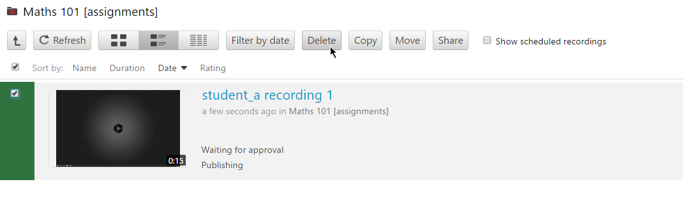

Allow all users in an assignment folder to view other users' content
By default, student created videos are only visible by faculty. If you want students to see each other’s video then follow these steps:
- Click on the Settings in the assignment folder you created. The default is that this setting is not enabled, and students cannot see each other assignments. Click on the box to enable “Allow viewers to see each other’s sessions”.
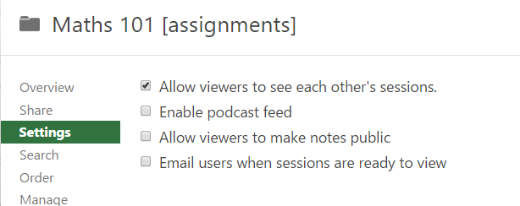

Closing an assignment folder
If you want to stop students from recording or uploading any more videos to the assignment folder, you can close the folder:
- Go to the class folder and click on settings.
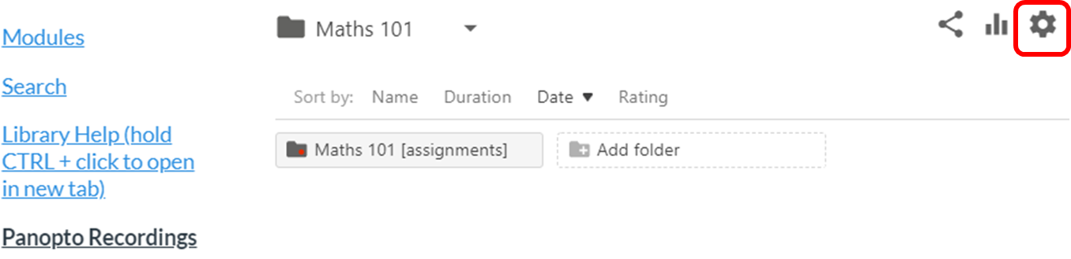
- On the Overview screen, scroll down to where it says Assignment Folder. You will see the word Close. Clicking this will prevent viewers of the folder from accessing and adding content to the assignment folder, but as the creator, you will still have access.
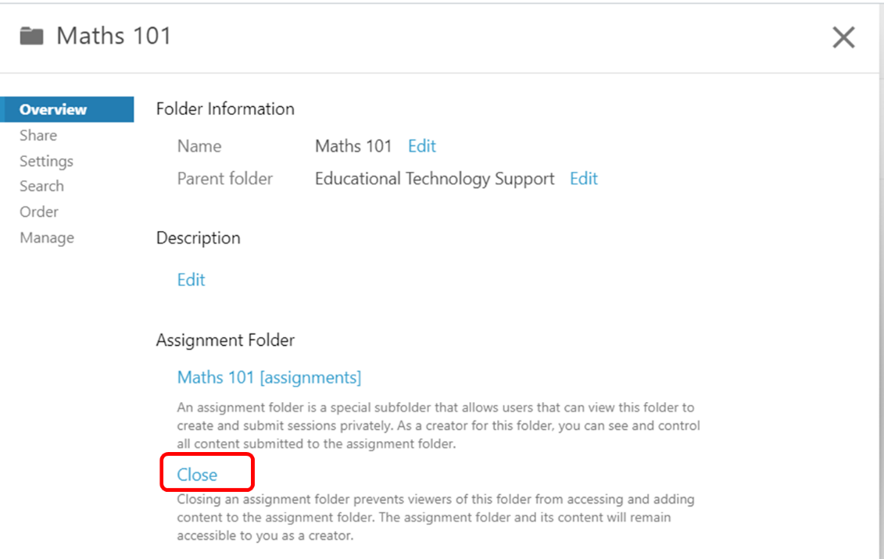
For more information on Panopto, please contact Diana Benavides. Diana.Benavides@seattlecolleges.edu. Ext: 3724

