Student Zoom User Guide

As you know by now, NSC classes will be held virtually starting (date) which means we will have class during our regularly scheduled time, only it will be virtual; this message provides some instructions for our (type day) class. As virtual teaching/learning might be new to many of us, let’s please bear with and help one another as we explore these relatively uncharted waters. For class on (type day), we will be using Zoom, a video conferencing tool.

What You Need to Get Started:
- An internet connected computer, laptop, or device
- Your meeting ID number or URL of the meeting (it will be posted in the Canvas announcements)
- A headset or ear buds (if you’re participating with a laptop)

Download and Launch the Zoom App:
Video tutorial on the following steps: https://youtu.be/vFhAEoCF7jg
- Click the link or URL to the Zoom room posted by your instructor.
- You will be prompted to download the Zoom application.
- Download the Zoom application.
- Click the URL of the zoom room again.
- Launch Zoom application from your browser.

Download and Launch the Zoom Mobile App:
The Zoom mobile app is available for both iOS and Android devices.
- For iOS, search "Zoom" on Apple AppStore or open Safari, and enter zoom.us. It will direct you to http://itunes.apple.com/us/app/zoom.us-cloud-video-meetings/id546505307
- For Android, search "Zoom Meetings" on Google Play. It will direct you to https://play.google.com/store/apps/details?id=us.zoom.videomeetings

The Zoom Control Bar:

The Zoom control bar appears at the bottom of the Zoom window once the meeting begins. If you don’t see the control bar, move your mouse slightly and the bar will appear. (The bar disappears after a few seconds when in full-screen mode.)
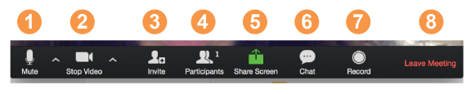
With the Zoom Control Bar, you are able to do the following:
- Mute/unmute your audio (not the audio of the participants). You can also select you audio input here by clicking the up arrow next to the microphone icon.
- Start/stop your video. You can also select you video input here by clicking the up arrow next to the video camera icon.
- Invite more people to join by email, IM, or meeting ID Student ZOOM User Guide
- View a list of participants.
- Share your desktop (everything you have open) or select a specific application to share (e.g., Microsoft Word).
- Send a message to one person (using private chat) or to all participants.
- Record the meeting (if you have been granted permission) 8. Leave or end the video meeting.

Switching Between Views (Share Screen and Video):
As a participant you might be asked to share your desktop or an application. During a meeting you can switch back and forth between sharing your screen and sharing your video as often as needed.
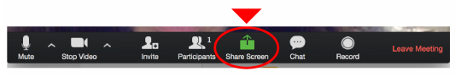
If you are in video mode, switch to screen share by clicking “Share Screen” in the control bar as shown: A window showing all possible options to share displays like below. Click on the item you want to display, which will be highlighted in green, then click “OK”:
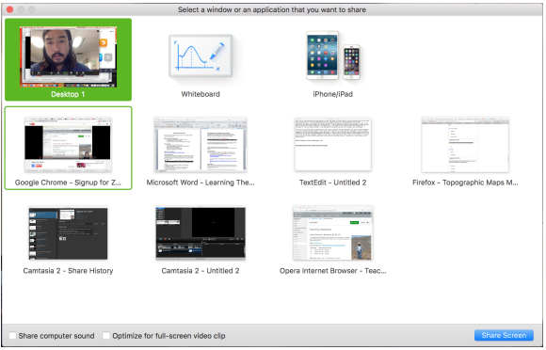
If you are displaying your screen, switch to video by clicking “Stop Share” from the menu at the top of the screen shown in the red box:
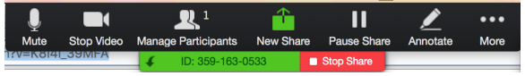

Helpful Tips:
Video conferences are a great way to meet - and stay connected with - your classmates and instructor. To make sure you get the most out of every session, keep the following tips and tricks in mind:
- Find a quiet location from which to join your session, and make sure you have access to a fast-wired internet connection or excellent Wi-Fi signal.
- Log in to every session using your full first and last name.
- Join a session a few minutes early to test your audio and video connections. You should also make sure you have the latest Zoom app downloaded (Zoom.us menu > Check for updates)
- Use a headset (or earbuds) instead of speakers and a microphone. The connection may sound fine to you, but speakers and a microphone generate too much static for others.
- Mute your audio unless you are speaking (or in line to speak) to prevent unintentional background noise from disrupting the conversation.
- When video is enabled, speak to the camera (and not to the screen).

If you have any more questions or run into issues, feel free to contact your instructor or eLearning for support. North.elearning@seattlecolleges.edu (206) 934 3738

